
http://www. www.firenzetoday.it

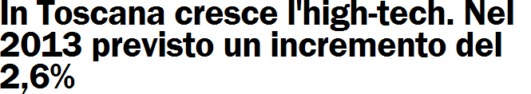



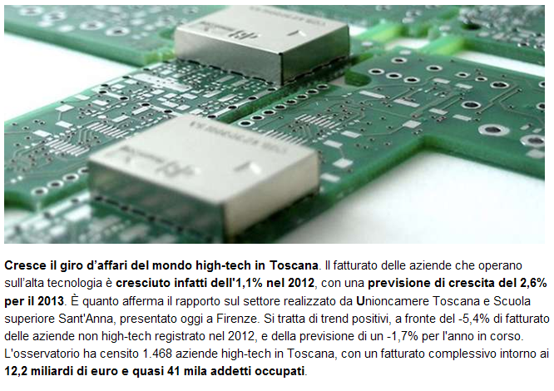

http://www. www.firenzetoday.it

